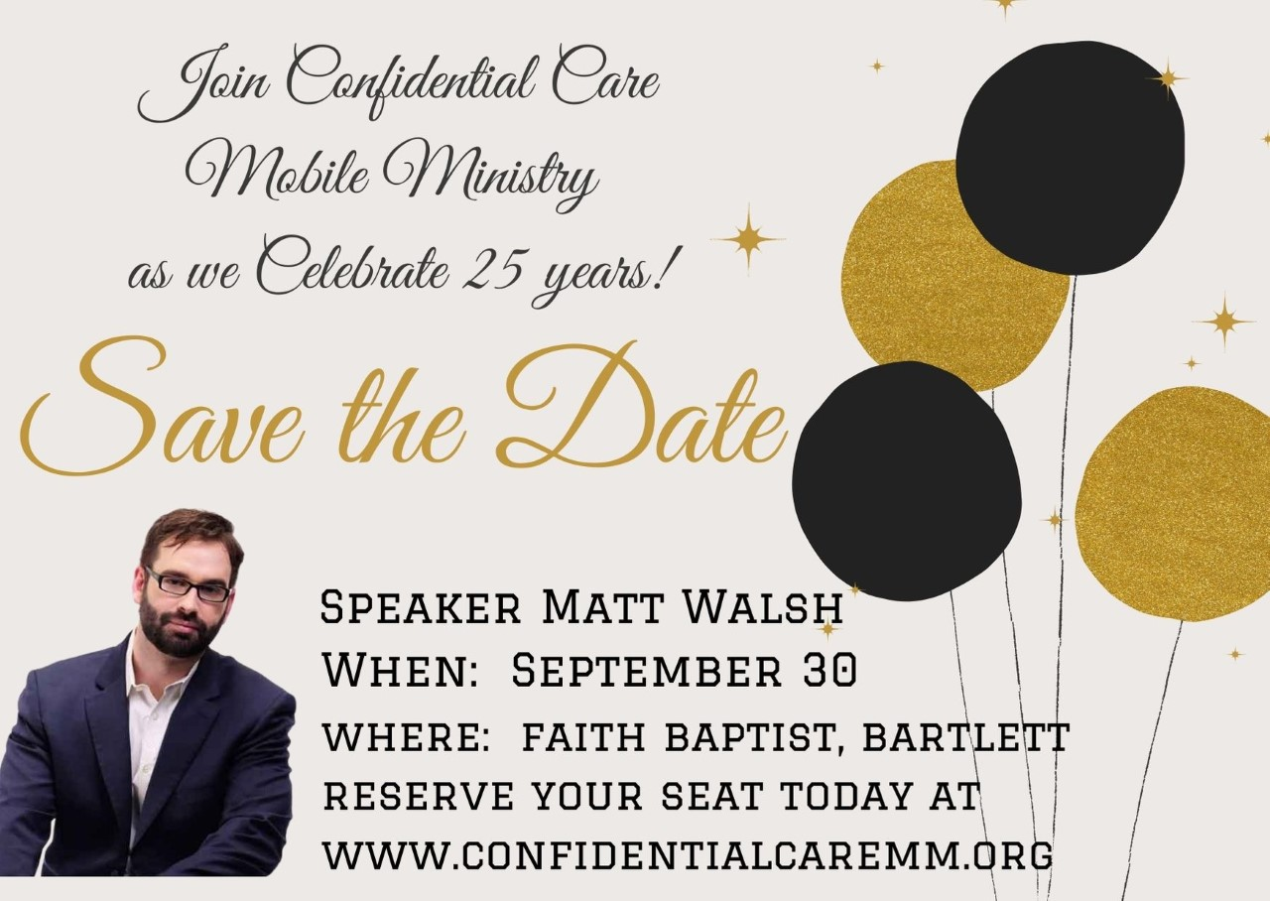
Matt Walsh is one of America's premier conservative authors and speakers who is known for boldly tackling the tough subjects and speaking out on faith and culture in a way that connects with and actuates his audience. You can follow him on Twitter at @MattWalshBlog and on Facebook at https://www.facebook.com / The Matt Walsh Show | The Daily Wire
Confidential Care Mobile Ministry is a Christ-centered, non-profit Mobile Pregnancy Medical Center that utilizes state of the art technology to meet the needs of families experiencing unplanned pregnancies assuring each preborn Human Baby gets to exercise their most basic human right – the Right to Life. Every day of every workweek CCMM sends out Medical Mobile Units primarily to the four corners of Shelby and Tipton Counties, to meet with Women in pregnancy crisis who have scheduled an appointment with our organization and have expressed a desire to abort their preborn child. Each of our Medical Mobile units are equipped with Ultrasound equipment and are staffed by Medical Ministry Teams, (MMT’s), which include a licensed Registered Nurse, and a Patient Care Advisor. Our Mission is: to rescue Preborn Human Babies from certain death and love their mothers into the Kingdom.
What: Annual Benefit Fundraising Celebration on behalf of Confidential Care Mobile Ministry featuring keynote speaker Matt Walsh
When: Thursday, September 30th, 7:30 PM doors open at 7:00PM
Where: Faith Baptist Church, 3755 Germantown Rd, Bartlett
Register online at www.confidentialcaremm.org, or ph. Shela Williams at (901) 476-6528
THIS CELEBRATION EVENT IS FREE! However, this is Confidential Care Mobile Ministry’s premier annual fundraising event, so please come prepared to give a generous love offering.

